Quality and Pricing in a variety seeking market

Ying Wei
School of Management, Department of Business Administration, Jinan University
Guangzhou, China
yingwei@jnu.edu.cn
Liyang Xiong
School of Management, Department of Business Administration, Jinan University
Guangzhou, China

Abstract: we study competitive quality and pricing strategies in markets where consumers seek variety. Variety seeking behavior is modeled as a decrease in the willingness to pay for product purchased on the previous occasion. Using a three-stage Hotelling-type model and it assumes that consumers have the different preference for the two retailers. We find that on the level of price the gap of price of two retailers is decreased by the variety seeking behavior, and the average price is lower in period 2. Then on the level both of quality and price, it promote the difference of two retailers, one retailer that consumers have more preference supply the high quality and high price commodity, the other one make the completely opposite decision of it. It shows that the quality in period 2 is higher than that in period 1. Further, the total profit of the differentiated market is more than that of non-differentiated market. Therefore, the presence of variety seeking consumers benefits everyone in the market.
Key words: variety seeking; quality; pricing; brand propensity; hotelling models;

I.Introduction
Observed brand choice behavior suggests that some consumers avoid changes and it exist different propensity for brand, whereas some consumers prefer variety. Preference for variety, observed even in the absence of stock outs and promotions (Bass et al.1972), is believed to indicate the presence of a variety seeking trait in consumers (e.g., Givon 1984, Lattin and McAlister 1985). Consumers have the different propensity brand when the commodity has the same price and the quality (Che 2007, Kahn 1995). Marketing has a rich tradition of empirical research that allows us to estimate the extent of variety seeking in a market (e.g., Kahn et al. 1986, Trivedi et al. 1994). In brand of clothing, Nina (2009) explore the impact of internal factors such as variety-seeking drive, loyalty, perceived risk, and similarity perceptions on brand-switching propensity suing multiple, it found that retailers should ensure that their clothing brands or stores are among those in the multi brand repertoire of the consumer. For example, on the same price level, some consumers want to buy Adidas cloths and others want to buy Nike cloths.
Previous literature has identified a number of psychological processes leading to variety seeking tendencies within individuals. Utpal (2010) seek the implication of consumers’ behavior in a Multichannel, Multimedia Retailing Environment. Consumers seek to maximize utility from switching brand by seeking variety behavior (Oliver 2012). Generally, consumers may get satiated when purchasing the same item again (McAlister 1982), however, the seeking variety was not only in the different brand or items, but also in goods, service and others (Barbara 1995). For example, the store environment has an important impact to purchasing for seeking variety (Geetha 2012). In marketing literature, it explains why switch in product category-level and in individuals for true variety-seeking behavior (Han C.M 1996). Actually, the purchase quantity and timing also have a great effect for variety-seeking behavior (Itamar 1990), purchasing several items one time on one shop may spend less time but decrease the variety-seeking behavior, the other did not.
The reasons why variety-seeking behavior exists? Generally, it is for lower price, new brand, new experience, new service or others. For example, in period 1, consumers buy goods in A retailer as X price, but he thinks the price may be lower in B retailer in period 2. P. B. Seetharaman (2009) explore the effects of variety seeking on price competitions in duopoly market, with two situations of functionally undifferentiated products and functionally differentiated products, and the two firms locate at extremes of the market. Furthermore, S. Sajeesh (2010) does not restrict firms to locate at the extremes of the market, the firms’ location represent the differentiation, both the locations and pricing are decisions. The variety seeking not only makes the pricing lower, but also improves service quality and customer satisfaction (Carmen 2001). For example, in internet industries, the transmissions costs is very low, consumers want to gain maximized utility by variety seeking, it urges operators to make low price and high quality service (Andrew 1998), the consumers is heterogeneity in the market, some people want to low quality service for low price, but others don’t think so, operators may supply a differential strategy to meet every consumers, or an uniformly strategy, it showed that the uniformly strategy may well be best in the long run (Peter 2000).
In duopoly market, it, generally, suppose that the consumers are distributed uniformly between the two firms or the firms’ locations are uncertain (John 1996). Previously, the researches showed that it has no location-price equilibrium in pure strategies; many literatures transform the location form line to parallel line or circle to address this equilibrium (Amoz 1994, Tao 2009). For the differentiated duopoly market, most papers make the firms’ locations are fixed, some researched the affect of pricing and quality and it thinks that Personalized Pricing may increase product differentiation and an overall increase in consumer welfare with competing firms (Vidyanand 2005). Desai (2001) research the optimal strategy when the consumers either choose the high quality and high price product or low quality and low price product in the competing firms of duopoly.
Overall, we build the work of Sajeesh (2010) and Desai (2001), and develop this model that it restrict firms to locate at the extremes of the market and allows firms to make pricing and quality (or service) decisions in the context of a consumer variety seeking behavior model, furthermore, we assumed that the preferences of consumers to the two firms is not same that they may like to buy the same products in A firm when they gain the utility from the quality and pricing of two firms, previous research showed that the total utility of consumers gained form the same price and quality product, less literatures considered the brand’s effect. And more researches explored the varied of price in period, however, we find that most products’ quality were changed instead of pricing, our model filled this gaps, the results were consistent with empirical studies, In the differential duopoly market, the different quality products satisfied the different consumers and make the total profit higher than the uniformly products. We also find that the average quality level was improved when the consumer behavior exists. In our model, two firms increased the gaps of quality and price to prevent the variety seeking consumers from switching to the competing products or focus the different level consumers.
The rest of this paper is organized as follows. In the next section, we outline the key features of our competitive model, in section 3, we analyze the model and derive our main results and outline the intuition behind the results. In section 4, we make the numerical analyze. At last, it presents the conculsions, limitations and possible avenues for future research.

II.Model
We use the Hotelling framework (Hotelling 1929) and assume that the market consists of two symmetric firms, A and B, earch offering one product, denoted by superscripts A and B, respectively. We restrict firms to locate at the extremes of the market. Consider two decision situation and the following sequence of decisions. In the first decision situation that the quality is not the decision variable, in period 1, firms choose first-period prices, 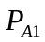and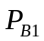, and consumers buy the product that maximizes their utility. In period 2, firms choose second-period prices, 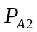and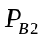, and consumers again decide to buy the product that maximizes their utility. In the second decision situation that the firms tried to change their quality to maximize their profits, in period 0, firms choose prices simultaneously. In period 1, firms choose first-period quality, 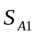and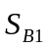, and consumers buy the product that maximizes their utility. In period 2, firms choose second-period quality, 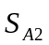and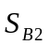, and consumers again decide to buy the product that maximizes their utility. Multi-period models have been used extensively in marketing literature (Desai and Purohit 1999). The specific model assumptions are described below in greater detail.
- We assume that consumers are distributed uniformly over a unit interval [0, 1], and the total number of consumers is normalized to 1. A consumer’s position on the line represents the conveniences to buy products form each firms.
- We assume that in Period 1, consumer reservation price is denoted by , and is the same for both products A and B; is assumed to be sufficiently large so that all consumers buy one of two products in Period 1. Although consumers may buy at different times, Period 1 corresponds to the first purchase occasion for a particular cunsumers.
- For a fraction of consumers in the market, denotes that the variety seeking consumers, the willingness to pay for the product they purchased in Period 1 goes down by in Period 2 because of satiation or boredom. These consumers are distributed uniformly on the line segment [0, 1]. Thus, in the context of our model, a consumers’ position on the line represents the durable aspects of preference. Variety seeking is modeled as a temporary change in valuation rather than a permanent change in underlying product preferecves.
- The willingness to pay of the remaining 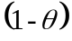 consumers is not affected by their past purchases.
- We model transportation cost in the following way. For any distance , transportation cost is given by 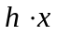(Subramanian 2013). If a consumer buys a product positioned at a distance away from her ideal point and priced at  and that quality at , she gets a net utility of 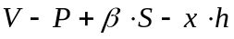, where is the utility that consumers get the product, and the 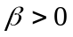 is the sensitivity of the quality.
- We assume that the consumers’ base propensity is different to each firm, thus, the net utility is 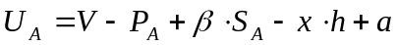 from firm A, the net utility is 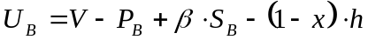 from firm B. If , then, all else being equal, consumers on average have a higher propensity to firm A, they will get more utility form firm A. If 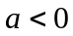, then, on average, all else being equal, consumers have a higher propensity to firm A, they will get more utility form firm B. We consider 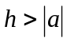, denotes that, all else being equal, the consumers will purchase the product from the each firm instead of one of the two firms.
- The production cost functions are identical for both firms, the marginal cost of producing a product of quality is 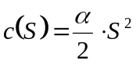(Desai 2001). Other cost is assumed to be zero without loss of generality.
- Firms have rational expectations and maximize the total profit in Period 1 and Period 2. Consumers are rational in the sense that each consumer’s choice problem is to purchase one product from either firm in each time period that maximizes utility in that period.

III.Analysis
Because it is a multistage game, we use the concept of subgame perfect equilibrium and analyze the decisions of firms and consumers in the reverse order to solve for equilibrium in prices and quality. Firstly, we discuss 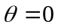, case which provides us the benchmark against which our results are compared.
Case 1:
Note that represents absence of variety seeking (a situation where consumers’ willingness to pay in Period is not based on what they bought last period). The utility that consumer get from each firm. Specifically,
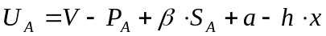
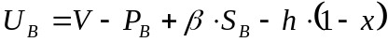
Consumers will purchase product from firm A when 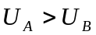:
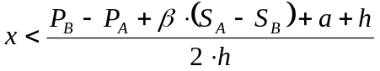
Therefore, the each firm’s demand is
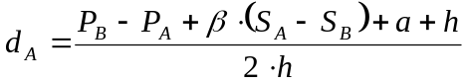
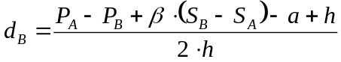
Firm A and Firm B profits are respectively given by
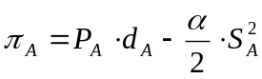 (1)
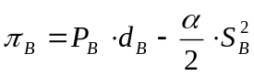 (2)
Firm A and Firm B will choose 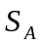 and 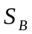 to maximize profits. Therefore, 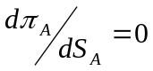. Similarly, 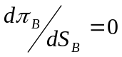. Solving these simultaneously, we get
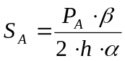 (3)
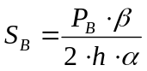 (4)
Then, Firm A and Firm B will choose 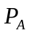 and 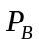 to maximize profits. Therefore, 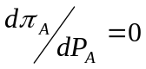. Similarly, 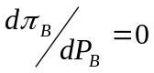. Solving these simultaneously, we get
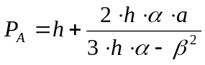 (5)
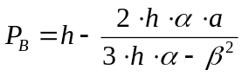 (6)
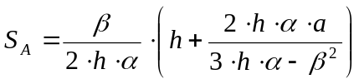 (7)
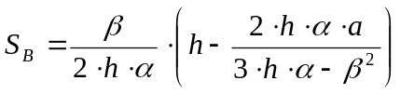 (8)
Theory 1: when the consumers are more sensitivity to quality (the  is increasing), the gap of prices( and 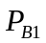) and quality( and ) are increasing, specially, the market differentiation become more and more bigger.
Assuming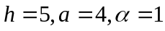, the and , and as changes for(chart 1 and 2)
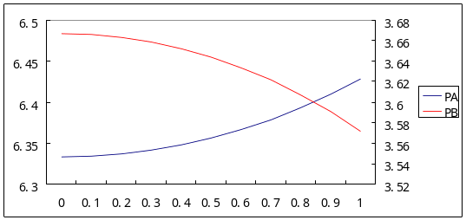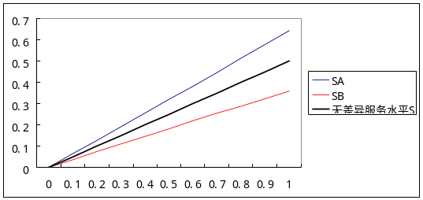
Chart 1 Chart 2
Based on our previous propositions, when the consumers become more sensitivity to quality, the Firms do not only compete in price, the competition becomes more diversification, it prevents the malignant competition in price.
Case 2: 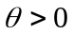
We have a three-period game (Period 0, 1 and 2). In Period 0, firms choose prices. In Period 1, the consumers purchase the product that provides them with the highest utility. In Period 2, some consumers’ buying behaviors based on what they bought last period. As we known, Firm A demand comes from three types of consumers.
Type 1: Among the consumers who has no variety seeking, consumers will buy from Firm A if buying from Firm A provides them with higher utility in period 2. These consumers equal
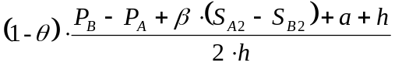
Type 2: These are variety seeking consumers who purchased from Firm B in period 1, and because satiation with Firm B’s product, their net utility is higher in Period 2 by buying from Firm A. This fraction of consumers equals
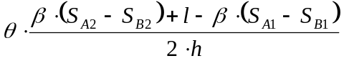
Type 3: These are variety seeking consumers who buy from Firm A in period 1 and continue to buy from Firm A. These consumers equal
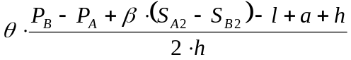
Adding the demand from these three different types of consumers, total Firm A demand in Period 2, denoted by 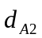, are given by
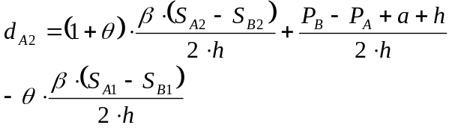
Similarly, Firm B sales in Period 2 can be expressed as
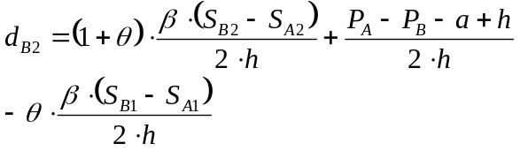
Therefore, Firm A and Firm B profits are respectively given by
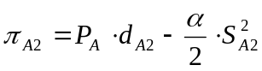
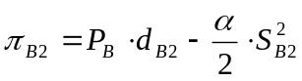
In the second period, firms choose 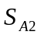 and 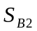 to maximize profits assuming Period 1 prices are given. We find and to be as follows:
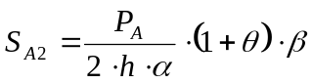 (9)
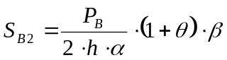 (10)
The each firm total profit in Period 1 and Period 2 is
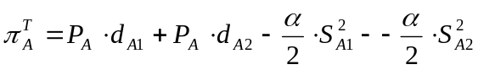
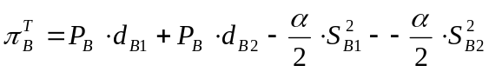
In the first period, firms choose 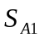 and 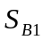 to maximize profits. We find and to be as follows:
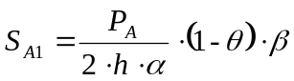 (11)
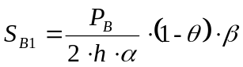 (12)
Thus, firms choose and to maximize profits. We find and to be as follows:
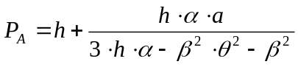 (13)
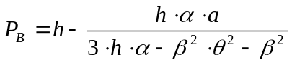 (14)
Theory 2: when 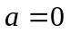，which the consumers have the same the propensity to each firm, as the increased, the quality of variety seeking in Period 1 is worse than that of no variety seeking (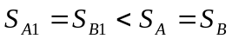), the quality of variety seeking in Period 2 is better than that of no variety seeking (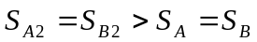).
Deduction 1: when ，which the consumers have the same the propensity to each firm, the variety seeking do not affect the prices, however, the quality become better, so the consumers’ surplus are increased.
Theory 3: when 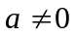，which the consumers have the different the propensity to each firm, as the increased, the gap of prices become more bigger (and), the become high, the become low, as same the quality (and), and both of the firms’ quality (and) become better.
Theory 4: when ，the total profit of market is more than that of no different propensity market(), as the increased, the gap of the total profit become more bigger, the different propensity market show better than the same propensity market.
Deduction 1: no matter or , the consumers’ surplus are increased.
Assuming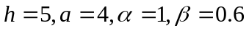, the and , 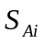 and 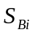(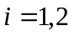) as changes for( chart 3 and 4)
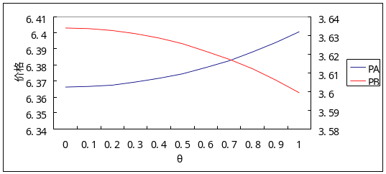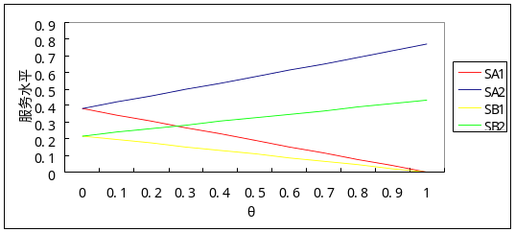
Chart 3 Chart 4

IV.Summary and Conclusion
We study competitive pricing and quality strategies in markets where consumers seek variety. Our results showed that variety seeking promote the difference of markets, quality and reduce the price, consumers can get more net utility, in this paper, we consider that the price is committed, that in period 2 the price is same as the last period. As future research, we will consider this situation that the quality is committed, or the price is committed in one firm and the quality is committed in the other one.

References
[1]Oliver Meixenr, Viktoria Knoll. An expanded model of variety‐seeking behavior in food product choices[J]. British Food Journal, 2012, 114(11)1571-1586.
[2]Barbara E Kahn Meixenr. Consumer variety-seeking among goods and services[J]. Journal of retailing and consumer services,1995,2(3)139-148.
[3]Geetha Mohan, Bharadhwaj Sivakumaran, Piyush Sharma. Store environment’s impact on variety seeking behavior[J]. Journal of retailing and consumer services,2012,19,419-428.
[4]Itamar Simonson. The Effect of Purchase Quantity and Timing on Variety-Seeking Behavior[J]. Journal of Marketing Research,1990,2(27)150-162.
[5]Nina Michaelidou, Sally Dibb. Brand switching in clothing: the role of variety-seeking drive and product category-level characteristics[J]. International Journal of Consumer Studies,2009,33,322-326.
[6]Utpal M. Dholakia, Barbara E. Kahn, Randy Reeves. Consumer Behavior in a Multichannel, Multimedia Retailing Environment[J]. Journal of Interactive Marketing,2010,24,86-95.
[7]Bass, F., E. A. Pessemier, D. R. Lehmann. An experimental study of relationships between attitudes, brand preference, and choice[J]. Behavior Scinece,1972,17(6)532-541.
[8]Givon, M. Variety seeking through brand switching[J]. Marketing Scinece,1984,3(1)1-21.
[9]Lattin, J. M., L. McAlister. Using a variety-seeking model to identify substitute and complementary relationships among competing products[J]. Marketing Research,1985,22(4)330-339.
[10]Che,H.,K. Sudhir. Bounded rationality in pricing under state dependent demand[J].Marketing,2007,44(3)434-449.
[11]Kahn, B. E. Consumer variety-seeking among goods and services[J]. Retailing Consumer Services,1995, 2(3)139–148.
[12]Kahn, B. E., M. U. Kalwani, D. G. Morrison. Measuring variety-seeking and reinforcement behaviors suing panel data[J]. Marketing Research,1986, 23(2)89–100.
[13]Trivedi, M., F. M. Bass, R. C. Rao. A model of stochastic variety-seeking[J]. Marketing Science,1994, 13(3)274–297.
[14]Hans C. M. Van Trijp, Wayne D. Hoyer, J. Jeffrey Inman. Why Switch? Product Category: Level Explanations for True Variety-Seeking Behavior[J]. Journal of Marketing Research,1996, 33(3)281–292.
[15]P. B. Seetharaman, Hai Che. Price Competition in Markets with Consumer Variety Seeking[J]. Marketing Science,2009, 28(3)516–525.
[16]S. Sajeesh, Jagmohan S. Raju. Positioning and Pricing in a Variety Seeking Market[J]. Management Science,2010, 56(6)949–961.
[17]Carmen Berne, Jose M. Mugica, M. Jesus Yague. The effect of variety-seeking on customer retention in services[J]. Journal of Retailing and Consumer Services,2001,8,335–345.
[18] Andrew Odlyzko. The economics of the Internet: Utility, utilization, pricing, and Quality of Service[J]. AT&T Labs - Research,1998.
[19] Peter C. Fishburn, Andrew M. Odlyzko. Dynamic behavior of differential pricing and quality of service options for the internet[J]. Decision Support Systems, 2000,28,123–136.
[20] John F.R. Harter. Hotelling's competition with demand location uncertainty[J]. International Journal of Industrial Organization, 1996,15,327–334.
[21] Amoz Kats. More on Hotelling's stability in competition[J]. International Journal of Industrial Organization, 1995,13,89–93.
[22] Tao Huang. Hotelling competition with demand on parallel line[J]. Economics Letters, 2009,102,157–159.
[23] Vidyanand Choudhary, Anindya Ghose, Tridas Mukhopadhyay. Personalized Pricing and Quality Differentiation[J]. Management Science, 2005,51(7),1120–1130.
[24]Desai P. Quality segmentation in spatial markets: When does cannibalization affect product line design?[J].Marketing Science,2001,20(3) 265–283.
[25]Upender Subramanian, Jagmohan S. Raju, Z. John Zhang. Exclusive Handset Arrangements in the Wireless Industry: A Competitive Analysis[J].Marketing Science,2013,32(2) 246–270.

